WORKBOOK ASSIGNMENT - 2

Q1) Create a database named CollegeDB and a table named Student. The table should contain the following columns: Column Name Data Type StudentID StudentName INT VARCHAR(50) Age Course INT VARCHAR(30) City Marks VARCHAR(30) INT Add a primary key on StudentID and insert at least 10 records.

CREATE DATABASE CollegeDB;
USE CollegeDB;

CREATE TABLE Student (
StudentID INT PRIMARY KEY,
StudentName VARCHAR(50),
Age INT,
Course VARCHAR(30),
City VARCHAR(30),
Marks INT
);

INSERT INTO Student (StudentID, StudentName, Age, Course, City, Marks) VALUES
(1, 'Alice', 20, 'BSc', 'Mumbai', 85),
(2, 'Bob', 21, 'BCA', 'Pune', 78),
(3, 'Charlie', 19, 'BSc', 'Delhi', 92),
(4, 'Diana', 22, 'MCA', 'Mumbai', 88),
(5, 'Eve', 20, 'BCA', 'Nashik', 74),
(6, 'Frank', 21, 'BSc', 'Mumbai', 65),
(7, 'Grace', 19, 'MCA', 'Pune', 95),
(8, 'Heidi', 22, 'BCA', 'Delhi', 81),
(9, 'Ivan', 20, 'BSc', 'Mumbai', 89),
(10, 'Judy', 21, 'MCA', 'Nashik', 76);
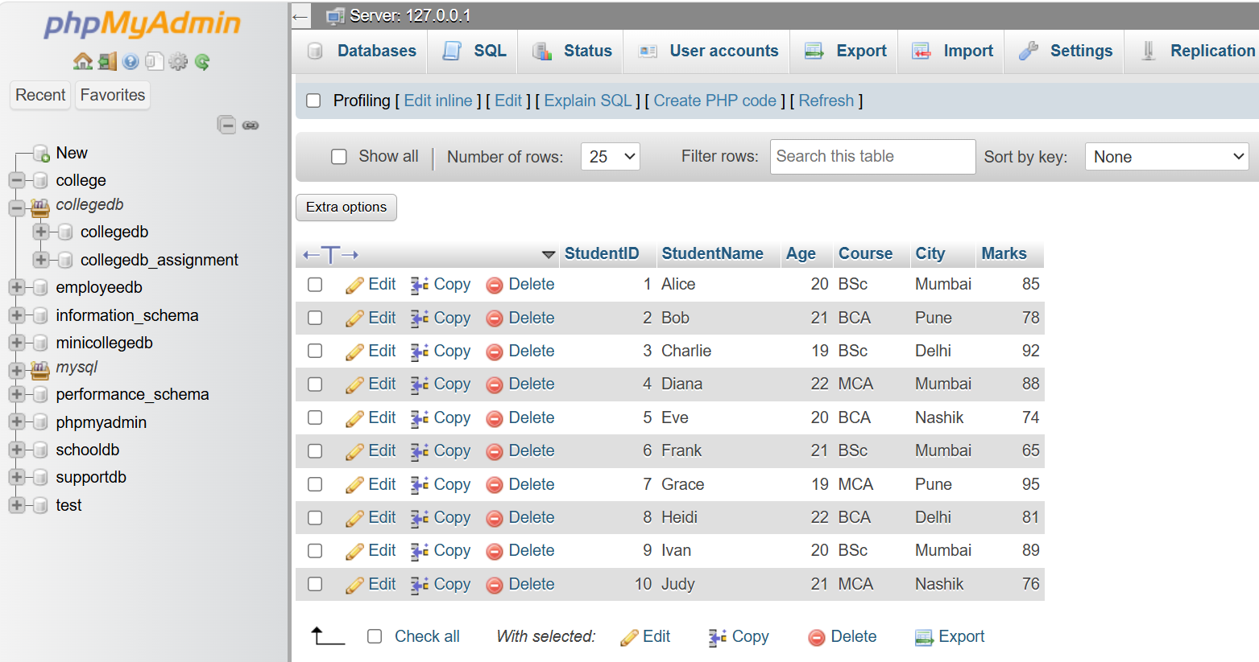

Question2.
Q2) Write a MySQL query to display all records from the Student table. The output should display all columns and all rows.
Select * from Student
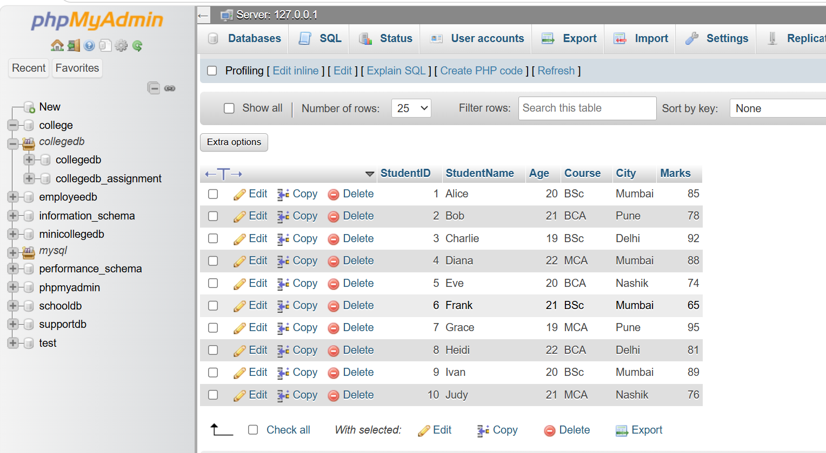

Question3
Q3) Write a MySQL query to display only the following columns: 1. StudentName 2. Course 3. City
Select studentName, course, city
From student;
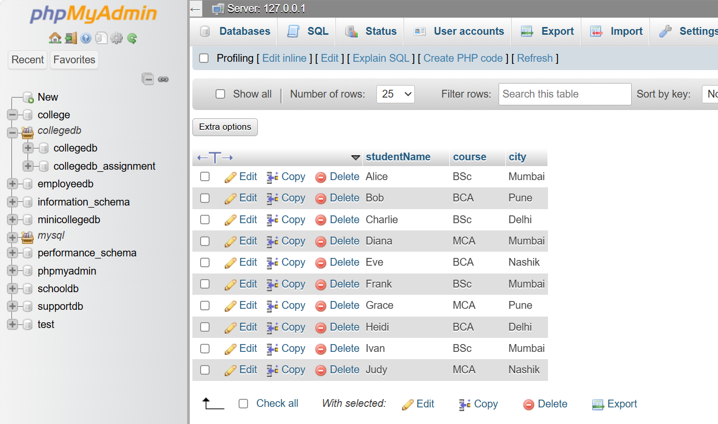

Question4
Q4) Write a MySQL query to display students who belong to the city Mumbai. The output should include: 1. StudentID 2. StudentName 3. City 4. Marks
SELECT StudentID, StudentName, City, Marks
FROM Student
WHERE City = 'Mumbai';
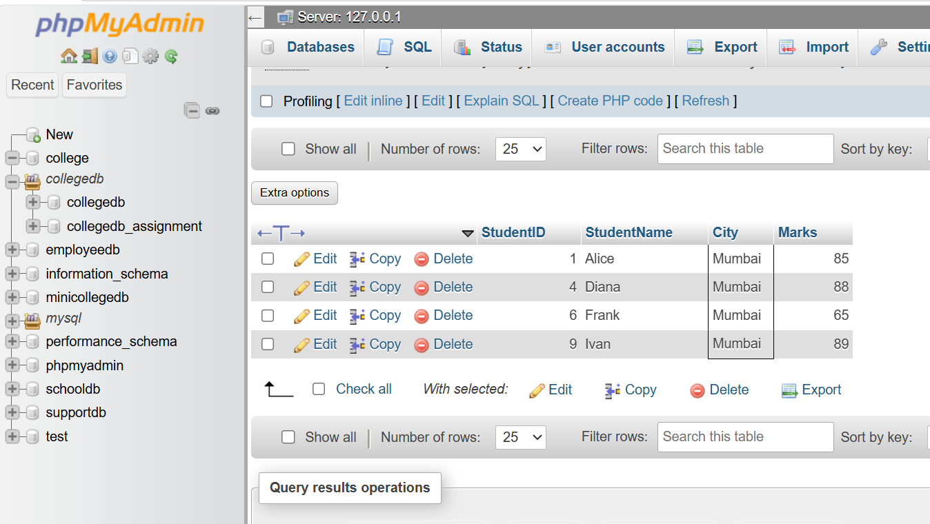
Question5
Q5) Write a MySQL query to display students whose marks are greater than 80.
The output should be sorted by marks in descending order.
Select *
From student
Where Marks > 80
Order by Marks DESC;
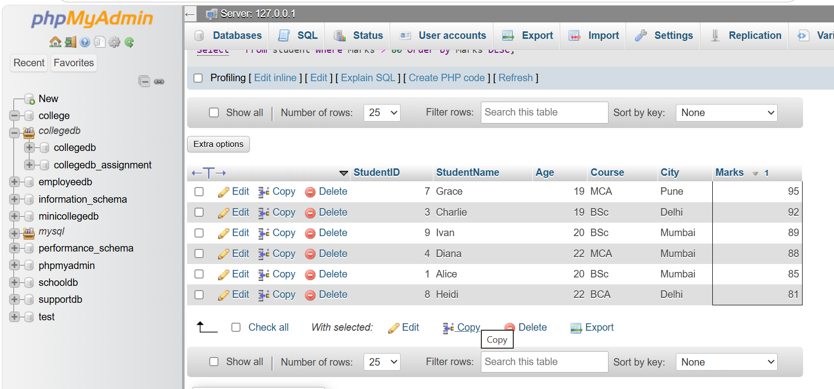

Question6
Q6) Write a MySQL query to display the top 3 students based on marks. The query should: 1. Display StudentName and Marks. 2. Sort marks from highest to lowest. 3. Display only 3 records using LIMIT.

Select studentName, Marks
From student
Order by Marks DESC
LIMIT 3;
